**241/2**

**HISTORY**

**WEST AFRICA**

Paper 2

Jul/Aug 2019

2 Hours

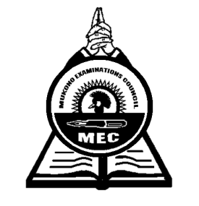

**MUKONO EXAMINATION COUNCIL**

**Uganda Certificate of Education**

**HISTORY OF WEST AFRICA**

**(C. 1000 to Independence)**

Paper 2

2 Hours

**INSTRUCTIONS TO CANDIDATES**

*Answer only* ***four*** *questions.*

*Any additional question(s) answered will not be marked.*

*All questions carry equal marks.*

1. a) Explain the importance of the Trans-Saharan trade to the people of West Africa.

***(15 marks)***

b) Why did this trade decline? ***(10 marks)***

1. a) Explain the contribution of Mansa-Musa to the growth of Mali empire. ***(13 marks)***

b) Why did the Mali empire decline? ***(12 marks)***

1. a) Describe the origin of the Oyo Empire. ***(10 marks)***

b) Why was the empire able to survive between 15th and 19th centuries? ***(15 marks)***

1. a) Describe the organization of the Triangular trade in West Africa. ***(13 marks)***

b) How did the trade affect the people of West Africa? ***(12 marks)***

1. a) What were the origin of the Creoles in West Africa? ***(10 marks)***

b) Explain the contribution of the Creoles to the development of Sierra Leone. ***(15 marks)***

1. a) How was Islam spread in West Africa up to the 18th century? ***(12 marks)***

b) What were the effects of the spread of Islam on the people of West Africa? ***(13 marks)***

1. a) Why was the 1884 – 1885 Berlin conference held? ***(08 marks)***

b) How did the results of the conference affect West Africa? ***(17 marks)***

1. a) How did George Maclean administer the Gold coast between 1830 – 1843? ***(15 marks)***

b) What problems did he face during his administration? ***(10 marks)***

1. Describe the;

a) social ***(12 marks)***

b) economic ***(13 marks)***

development in Senegal during the colonial rule.

1. a) Explain the factors that led to the growth of nationalism in West Africa. ***(13 marks)***

b) What problems did the Nationalists face? ***(12 marks)***

***End -***